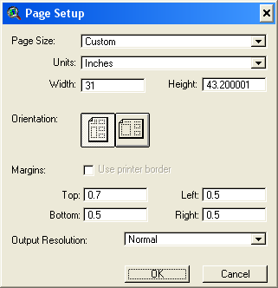

LARGE VIEWS----------------------------------------------------------------
TOP VIEW HOUSE of REPS
Origin: (1.00,22.09) in Extent: (27.00, 19.17) in Area 517.56

BOTTOM VIEW HOUSE of REPS
Origin: (1.00,8.50) in Extent: (23.50, 15.40) in Area 361.82
------------------------------------------------------------------------------------

CONTROL OF ----------------------------------------------------------------
2004 President
Origin: (24.75,25.47) in Extent: (5.00, 3.75) in Area 18.72

Control US Senate
Origin: (24.75, 21.36) in Extent: (5.00, 4.02) in Area 20.09

Senate
Origin: (24.75, 17.33) in Extent: (5.00, 3.80) in Area 18.96

Gov
Origin: (24.75, 13.37) in Extent: (5.00, 3.96) in Area 19.78

Control of State Leg
Origin: (24.75,9.35) in Extent: (5.00, 4.01) in Area 20.04

Control of State Senate
Origin: (24.75,5.38) in Extent: (5.00, 3.97) in Area 19.82

Control of Sate House
Origin: (24.75,1.30) in Extent: (5.00, 4.07) in Area 20.34

